ZH WIFI control card manual

First. Mobile edition App manual
The first step: you can scan the QR code and download the software of mobile version. The App is available in Android, tablet, iphone, or ipad

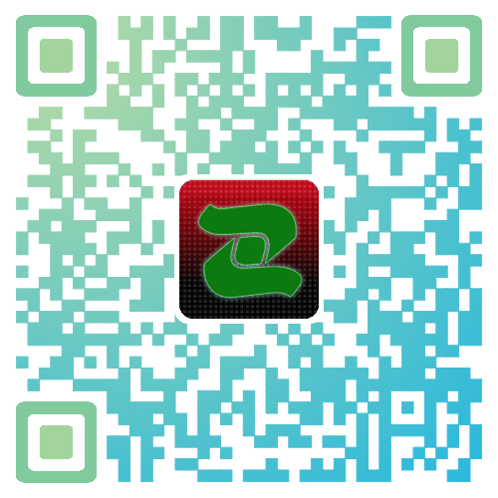

The second step: click finding button, select the name of ‘ZH_WX_XXX’ among the WiFi networks. when finding success, the software will read back the parameters of software configuration automatically ,then edit content, click the send button.
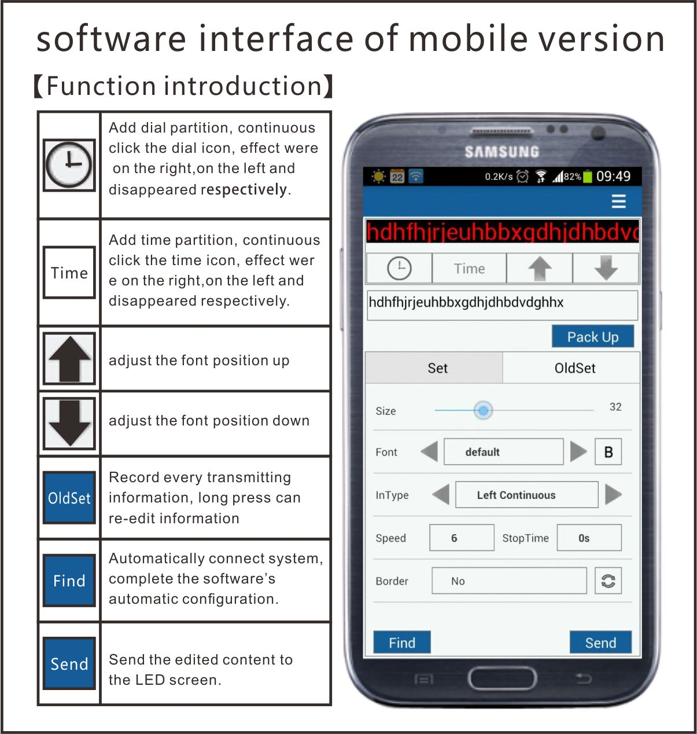

Second. Computer version software manual

Installation instructions: Go to our official website to download LED Control System V3.56: www.zhonghangled.com/en.
Step 1：after installing the software, double-click the icon to run the software.
Step 2: click the WiFi button in the software, select the name of ‘ZH_WX_XXX’ , the software will be connected to the WiFi ( In the XP system, you need to connect the WiFi manually .) When connection is successful, the system will prompt that it has detected the WIFI control system, click load parameters, the software will automatically read parameters and complete the software setting.
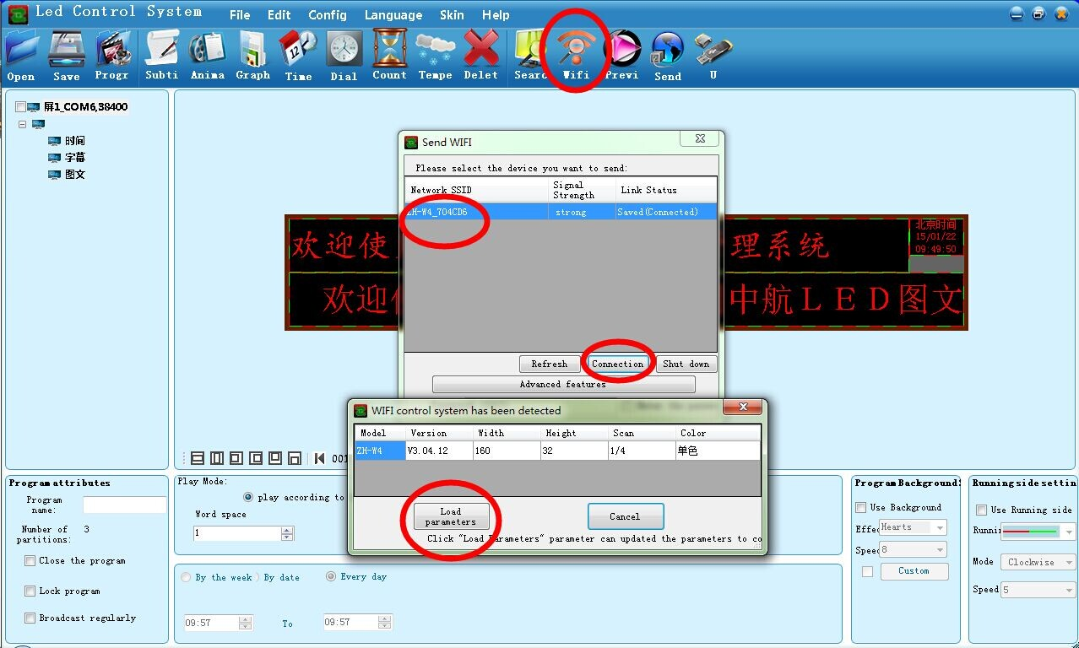

Step 3: Editing program, click ”subti” directly.
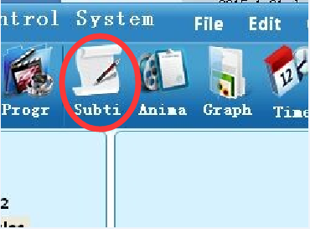
Click the toolbar horizontal expansion and vertical extension in the simulation of the display window, or put the mouse on the edge of subtitles to draw back the partition.
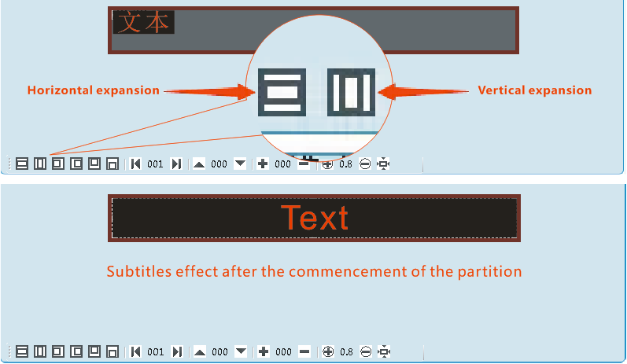

Input and edit the content to be displayed in the subtitle’s attribute box.

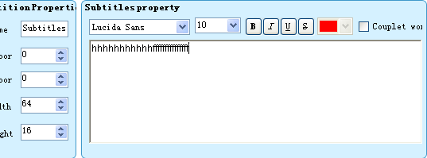

Select the desired effect, such as the common continuous left shift.
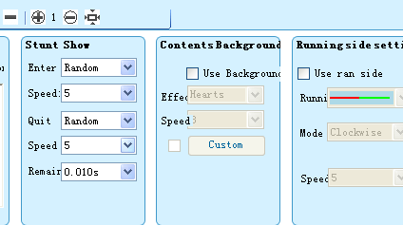

Step 4 sending content
Click the send button on the software - - Choose the corresponding WIFI Network -- Click send
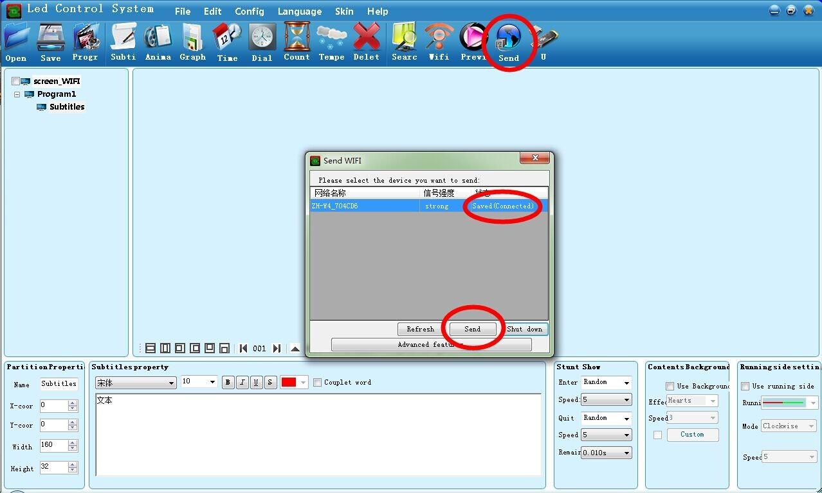
Note: The initial WIFI password is: 12345678, screen set password is: 168, advanced settings password is: 888, non engineering personnel recommended not to change the screen settings, in order to avoid abnormal display.

Common Problem ：
- What is the maximum that WIFI control system allows devices connected at the same time?
Answer: For security reasons, we allow up to four devices connected simultaneously.

- What to do when mobile phone users can’t see the control system’s network in the selection list of modules ?
Because the software will automatically open the WIFI, part of security software will prompt whether to allow the operation, if you choose to ban, this will happen. If users installed safe bodyguard app or other app in the mobile, please find the corresponding protection settings, and make sure the software is changed to trust.

- What to do if WIFI has connected but can’t find the control card?
The computer must be set to automatic access to IP, the specific operations are as follows: open network and sharing center -- wireless network connection -- attributes --internet protocol version 4(TCP/IPv4) attributes --automatically obtain the IP

- What to do if you can’t download the software by scanning QR code in WeChat?
Click the upper right corner on the download software page and select to open it in browser, you would be able to download software there.

